The Child Friendly Logo.
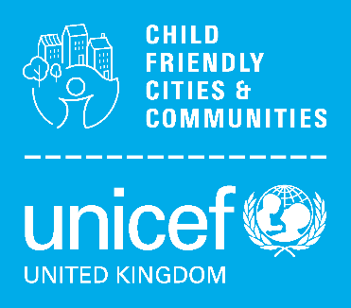

***(For completed workstreams***

***please use the Impact assessment template)***

Instruction – easy guide

Complete or working towards Nottingham becoming an accredited CFC

E.g. involvement of C&YP in decision making….

End – instruction … please email completed document to [child.friendly@nottinghamcity.gov.uk](mailto:child.friendly@nottinghamcity.gov.uk)

|  |  |
| --- | --- |
| **Title:**  *Event or workstream update* |  |
| **Date briefing submitted:** |  |
| **Background and context:**  *The purpose and why*  *Including badge and outcome below* |  |
| **Nottingham’s CFC Badge(s):**  **Equal and Included**  **Education and**  **Learning**  **Safe and Secure**  **Healthy**   * Safe and Secure * Healthy * Education and Learning * Culture * Co-operation and Leadership * Communication |  |
| **Outcome:**  *From Nottingham’s Action Plan* |  |
| **Event detail / Workstream update:**  *The how, what and when..?*   * *What has happened / is happening?* * *Who was / is involved?* * *What was / is in scope and why?* * *What engagement has / is taken / taking place?* * *Was it or is it successful?* |  |
| **Learning to date:**  *If applicable* |  |
| **Next Steps:**  *If applicable* |  |
| **Equal and Included is a Golden Thread**  *Please specify demographics, priority or under-represented groups relevant to the briefing* |  |

|  |  |
| --- | --- |
| *Consider the 7 principles of a Child Rights-Based Approach (details below).*  *Please write how and why the topic of your briefing demonstrates which of the principles in practice.* | |
| **Dignity** |  |
| **Participation** |  |
| **Life, Survival & Development** |  |
| **Non-discrimination** |  |
| **Transparency & Accountability** |  |
| **Best Interests** |  |
| **Interdependence & Indivisibility** |  |

